Creating a New Document

With Google Docs

- After logging into Google Docs, click the Create New button. A drop down list will appear.

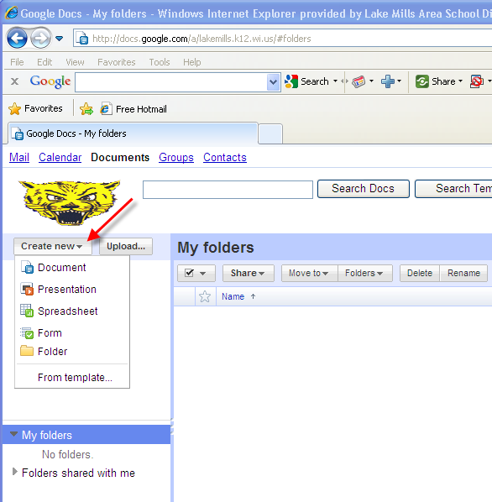

- Click on one of the document types (Text Document, Presentation, Spreadsheet, or Form). The document type that is selected will open in a new window.

